Quality Plan

*Southmansifield Inventory System*

**1. Introduction**

This document, together with other referenced documents, defines the responsibilities and procedures to be adopted to ensure that the data and information produced as part of Project 155 are reliable, fit for purpose and consistent with documented objectives and deliverables. It summarises the system of internal management that governs the decisions and instructions concerning project quality assurance.

**2. Project Contractual Information**

|  |  |
| --- | --- |
| Project: | Southmansfield |
| Project Number: | 115 |
| Programme Co-ordinator: | Mr. Joe Gene Quesada |
| Principal Investigators(s): | Mr. Manuel Sebastian |

**3. Scope of Work and Quality Objectives**

|  |  |
| --- | --- |
| Scope of work: | The scope of work for the Inventory System Project includes all the required modules: ordering, inventory and reporting. The Inventory System should contain the item descriptions, and complete inventory reports required by the client. The team AFKD will be responsible for analysing, designing, and building the Inventory System. Each added feature in the prototype should be approved by the Team’s adviser. The systems developer and systems designer ensures that each requirement would be met, and should each requirement would be tested. |
| QA Requirement: | To communicate more effectively with our client and redesign and publicise a new customer friendly website. |

**4. Project Organisation**

|  |  |
| --- | --- |
| Project Manager(s): | Armersson Caguioa |
| Task Manager(s): | Felix Gregorio |
| Quality Assurance: | Armersson Caguioa  Felix Gregorio |
|  |  |
| Other Team Members: | Daveson Romblon  (Project Analyst)  Karlo Luigi Mendoza  (Project Designer) |
| User Community: | Southmansfield College |
| Technical Reviews: | Mr. Joe Gene Quesada |

**5. Project Duration and Scheduling**

|  |  |
| --- | --- |
| Start Date: | August 22, 2016 |
| Completion Date: | Pending |
| Scheduling of Activities: |  |

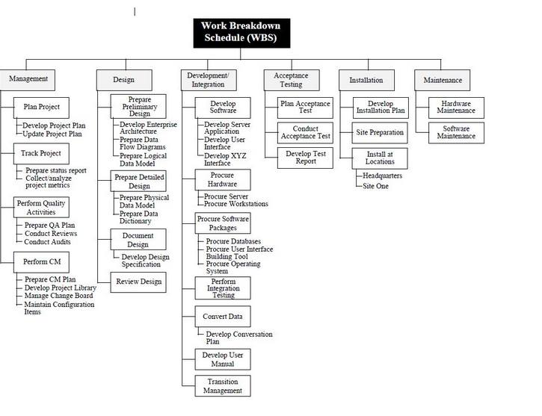

**6. Deliverables**

Deliverables specified for the project include:

a. Running System

b. Project’s Wiki

c. Project’s GitHub

d. Project’s OneNote

e. Progress Report

f. Vision and Scope Document

g. Project Statement of Work

h. Work Breakdown Structure

i. Gantt chart

j. Software Requirements Specification

k. Change Management Plan

l. Quality Planm. UML Diagrams

**7. Review of Quality Plan**

The team will review and will follow the quality plan provided by different quality gurus and will be analyse the system once every three months.

**8. Document and Record Control**

Project documents, data and records will be gathered in Asia Pacific College(APC) by team A.F.K.D. The document also must be labelled and organized properly and readily available for consultation by all members of team A.F.K.D. All documents will be uploaded to the Projects Wiki page of APC and frequently backed up by the individual members of the team.

The Quality Plan and Data Management Plan will be issued to all members of the consortium.

Project Progress Reports will be issued to the following:

* Armerson Caguioa
* Felix Gregorio
* Daveson Romblon
* Karlo Luigi Mendoza

**9. Documented Procedures**

The project team practice the Agile Methodology on project management to collaborate the

Prepared by: Date: 11/24/2016

Daveson Romblon

Checked by: Date: 11/24/2016

Felix Gregorio

Approved by: Date: 11/24/2016

Mr. Manuel Sebastian